Instalar o Angular Resource

Bower install angular-resource –save

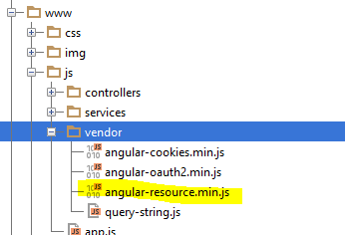

Chamar na index.html

<**script src="js/vendor/angular-resource.min.js"**></**script**>

Chamar na Dependência em App.js

angular.module(**'starter.services'**, [**'ngResource'**]);